Advice for Parents/Carers
Individual fashion statements such as extreme hair styles or colours, flamboyant hair accessories, and decorated footwear are not permitted.

Children who are not wearing the correct uniform should bring a note from home explaining the reason.

Uniform can be ordered through school or online through our supplier Elizabeth’s Embroidery www.elizabethsembroidery.com

Alternatively, uniform can be purchased from other retailers.

Thornhill Primary School
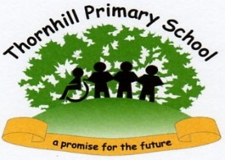

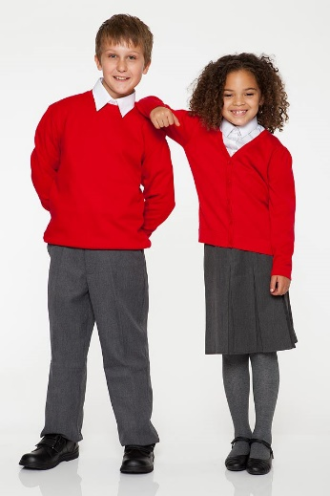

School Uniform
2022

Uniform Requirements
Why is uniform important?
The Thornhill Primary School uniform helps to distinguish our pupils from others in the area. Wearing uniform gives children a sense of pride and belonging which enables ALL children to feel part of our school family.
As a school, we believe that uniform is the practical and less expensive alternative to fashion clothing/shoes and as such will, in the long term, save our parents/carers money. All items should be labelled with your child’s name. Our school discourages the purchase of expensive items such as coats and jackets as the school cannot be held responsible if items go missing.
Our Uniform
It is important for children to come to school each day wearing clean uniform as listed below:
- Red or white polo shirt
- Red sweatshirt or cardigan
- Dark trousers/dark jogging bottoms
- Dark skirts/pinafore dress
- Grey/Red/Black tights
Please note that children must be able to put on and remove all items of clothing and footwear themselves.

School Shoes
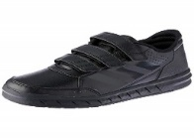
All classes have daily PE lessons, so children may wear dark trainers/leisure footwear for school. Trainers should have Velcro fastenings for younger children to ensure they are able to fasten their own shoes. Shoes/trainers must be plain with minimum decoration and logos.

School Bags
Pupils are given a plastic reading bag at the start of the year for reading books and home school diaries. School bags are not required.

Makeup and Jewellery
In the interests of Health & Safety, children are not permitted to wear jewellery and makeup, including nail varnish. If necessary we will ask parents/carers to come to school to remove ear studs and nail varnish. We recommend that ear piercing is done at the beginning of the 6 weeks holidays so that studs can be removed before children return to school in September. A simple watch which does not receive messages or connect to the internet may be worn.

Hair Styles
Hair must not be dyed, shaved, patterned, sculptured, or have styling products applied. ‘Mohicans, ‘Rats Tails’ and other extreme hair styles are not allowed. Hair should be neat (e.g. not over the face or eyes) and presentable and long hair should be tied back for Health & Safety reasons. Hair styles should be as simple as possible. Plaits (maximum of 2 only) with clips or bobbles are acceptable. Plain blue, black, brown or red clips and bobbles should be used. If necessary, we will contact parents/carers to discuss their child’s hairstyle.

Water bottles
Only water bottles up to 500ml can be brought into school. Any bottles larger than this are not allowed.

PE Kits
PE Kits are provided by the school. Children are encouraged to wear footwear suitable for PE and breaktimes, but they may borrow footwear if needed.

Weather
Please make sure your child is suitably dressed for the weather.
- Warm coat, hat and gloves in colder months
(including Wellies for snow/wet weather)
- Sunhat, waterproof jacket and suncream for warmer months.

