Newsletter

Website: www.thornhill.durham.sch.uk
Email: parents@thornhill.durham.sch.uk
Tel: 01388 772906

January 2023
Open mornings

We have hosted our Y6 and Y5 open mornings so far this term. It has been a great opportunity for parents/carers to get a flavour of their child's day at school, with opportunities to take part in a range of activities, use resources, look at pupil's work and displays and visit the classroom. It has been lovely to have families in school. Our next Open morning is Year 4 next week.
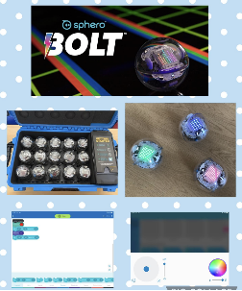
ICT resources

We have recently purchased a range of new ICT equipment, including an IPAD for all Year 5 and 6 pupils. In addition, we now have a wide range of robotic equipment in school including Kodapillar for EYFS, Dash Robots for Year 1 and 2 and Sphero Bolts for Year 3-6. These are excellent resources to help pupils learn about coding and algorithms, as well as using problem solving skills, which we know are vital skills for our pupil's future. There will be an opportunity at the open mornings to see and use our new equipment.

Chinese New Year

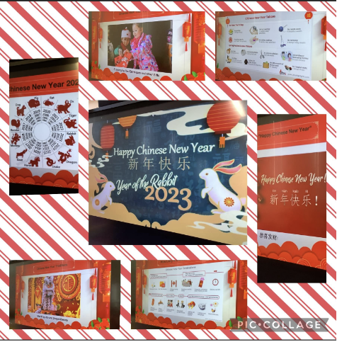
Chinese New Year began last Sunday and is the festival that celebrates the beginning of a new year on the traditional Chinese lunisolar calendar. We always enjoy learning about the traditions and cultures of this festival across the school. This week our Year 6 pupils were lucky enough to speak to a Chinese student at Durham University, who is from a small city located in the South east of China.
This year the Chinese zodiac is the Year of the Rabbit. People born in the Year of the Rabbit usually have soft and tender personality traits. They keep a modest attitude and maintain a pleasant relationship to people around. They will not be irritated easily, and they also avoid quarrels as much as possible.
To celebrate Chinese New Year, there will be a Headteacher competition to design a rabbit. Details are attached to this newsletter.

Pupil Voice
We value our pupil's opinions and contributions within school.
The School Council always do a fantastic job supporting new initiatives and are currently writing to local businesses to ask for any donations for books for our new school library. We also have our Eco-Councillors, who are developing a School Climate Action Plan, working with pupils, staff and Governors. At the moment, they are tackling food waste!
We also have our Buddies who do an amazing job at lunchtimes by organising playground games and checking all our pupils are having an enjoyable break.
A new group for this year is our Digital Leaders. They will be our advocates for ICT across the school and are very excited about their new role.
Well done to all the pupils involved in those groups!

Quick reminders

Earrings - Can we ask all earrings are removed for school please.
Hair Gel - No hair gel to be worn.
8.30am-8.45am - Please can children be supervised by adults on the yard at this time, as there are no staff on duty.

Spring 1 term

Thurs 2nd Feb Yr 2 Locomotion visit
Fri 3rd Feb Yr 4 Open morning
Tues 7th Feb Yr 6 Forest School
Fri 10th Feb Yr 3 Open morning
Swimming Gala (further info to follow)
Mon 13th Feb Yr 3 Dance Festival (further info to follow)
Parents Evening (Online)
Nursery meetings – in school
Tues 14th Feb Yr 5 Forest School
Move with Max Festival – Reception class (further info to follow)
Wed 15th Feb Yr 3 Dance Festival (further info to follow)
Parents Evening (Online)
Nursery meetings – in school

Close Friday 17th February 2023
Spring half term
Spring 2
Open Monday 27th February 2023

Tues 28th Feb Yr 4 Forest School
Wed 1st March Football League Yr3/4 (further info to follow)
Thurs 2nd March World Book day
Fri 3rd Mar Spring Music Festival (further info to follow)
Tues 7th Mar Yr 3 Forest School
Wed 8th Mar Football League Yr 3/ 4
Let Girls Play Football (further info to follow)
Fri 10th Mar Yr 2 Open morning
Tues 14th Mar Yr 2 Forest School
Wed 15th Mar Football league
Fri 17th Mar Yr 1 Open morning
Mon 20th Mar Yr 4 Tennis festival Bishop Barrington (further info to follow)
Tues 21st Mar Yr 1 Forest school
Fri 24th Mar Reception class Open morning
Mon 27th Mar Yr 5 Farm visit (further info to follow)
Tues 28th Mar Reception Forest School
Fri 31st Mar Nursery Easter Songs (further info to follow)
Yr 5/6 Girls football St Johns (further info to follow)

Close Friday March 31st 2023
Easter
Open Monday 17th April 2023

