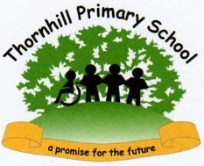
2023 Phonics Screening Test

Attainment of children in our school | 90%
Attainment of children Nationally (2022) | 75%

2023 Foundation Stage Profile

% achieving a Good Level of Development in our school | 65.5%
% achieving a Good Level of Development Nationally (2022) | 65.3%

