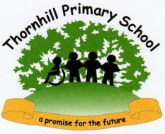**2025 Phonics Screening Test**

|  |  |
| --- | --- |
| Attainment of children in our school | 57% |
| FSM | 29% |
| Non FSM | 65% |
| Attainment of children Nationally (2024) | 80% |

**2025 Foundation Stage Profile**

|  |  |
| --- | --- |
| % achieving a Good Level of Development in our school | 64.3% |
| FSM | 37.5% |
| NON FSM | 75% |
| % achieving a Good Level of Development Nationally (2024) | 67.7% |