Autumn 1 | Autumn 2 | Spring 1 | Spring 2 | Summer 1 | Summer 2
Winnie the Look Up!  Witch  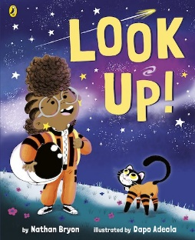  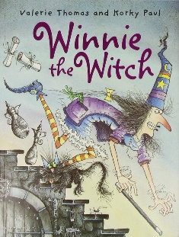 |  | The Owl who was The Most Important  Afraid of the Dark Animal of All  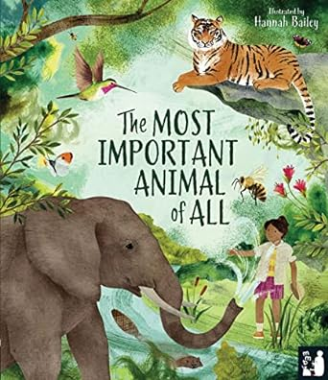  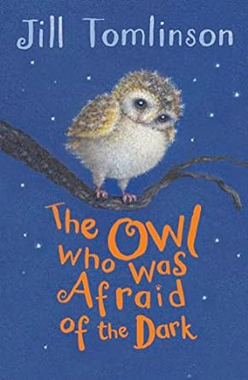 |  | 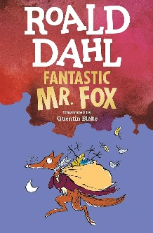  Fantastic Big Green  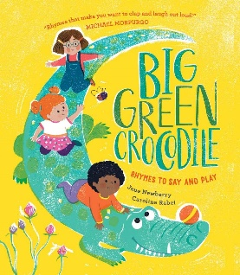  Mr. Fox Crocodile
Writing Focus
1. Character description – use of adjectives | 4. Persuasive Flyer to persuade people to join Rocket to see the Phoenix meteor shower. | 1. Character description – using alliteration. | 4. Non-chronological report. | 1. Character dialogue- conversation between Boggis, Bunce and Bean. Then innovate and write own conversation for three witches. | 4. Create an acrostic poem for wild animal.
2. Instructions for a magic potion. |  | 2. Recount main events of story. |  | 2. Invitation to Mr Fox’s amazing feast.
3. Dairy entry day in the life of Winnie or Wilbur. |  | 3. Innovate and write own story – Duck Afraid of Water. |  | 3. Film Review – compare the book and film – how are they the same, different.
Text Types
Fiction |  | Non-Fiction |  | Poetry
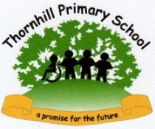
Year 2: Writing Overview

