Autumn 1 | Autumn 2 | Spring 1 | Spring 2 | Summer 1 | Summer 2
Matilda Little People,  Big Dreams  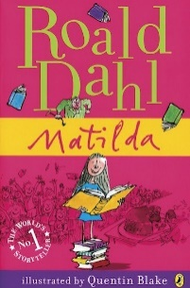  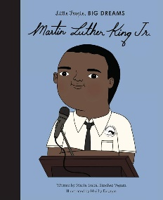 |  | The Firework- The Queen  Maker’s on our  Daughter Corner  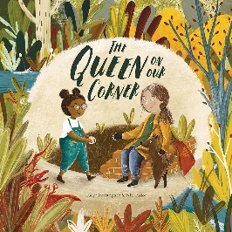  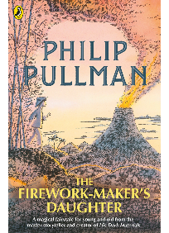 |  | Kensuke’s Michael Rosen’s  Kingdom Sticky  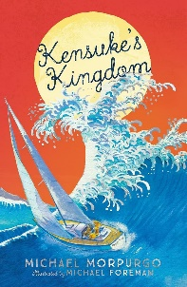  McStickstick  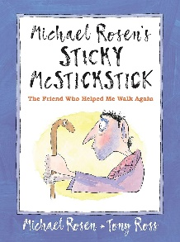
Writing Focus
1. Character description of Miss Trunchbull | 4. Biography of a famous person. | 1. Informal letter from Lila to her father. | 4. Newspaper report explaining the events of the fire. | 1. Ship’s Log entry for the first day at sea. | 4. An informal recount of a day in the life of Sticky McStickstick.
2. Diary entry from the perspective of Matilda on her first day attending Crunchem Hall Elementary. |  | 2.Poetry  Haiku & Kennings about the fireworks from the story. |  | 2. Play script based on the scene when Michael first met Kensuke.
3. Book review of Matilda by Roald Dahl. |  | 3. An information text about a famous volcano (Mount Merapi or Mount Vesuvius) |  | 3. Instructions for making a shelter or instructions on how to survive being stuck on a deserted island.
Text Types
Fiction |  | Non-Fiction |  | Poetry

Year 4: Writing Overview

