Autumn 1 | Autumn 2 | Spring 1 | Spring 2 | Summer 1 | Summer 2
Charlie and the Ruby’s Wish  Chocolate Factory  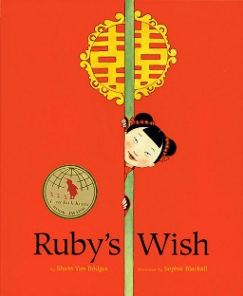  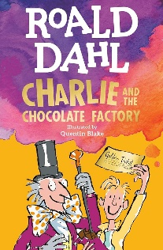 |  | A Shakespeare Story What’s so special  Romeo and Juliet about Shakespeare?  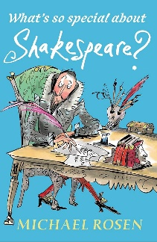  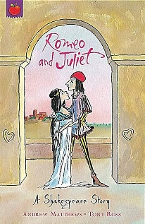 |  | Letters from Overheard in a  the Lighthouse Tower Block  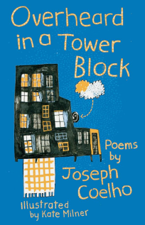  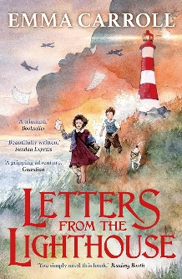
Writing Focus
1. Setting description  Chocolate room description. | 4. Interview/Podcast  Interviewing Ruby about her life. | 1. Playscript  Rewrite a scene from Romeo and Juliet. | 4. Shakespeare biography  Information about Shakespeare. | 1. Letter  Persuasive letter to the Ministry of Defence to convince them not to get rid of the lighthouse. | 4. Character description/wanted poster.
2. Summary of short story within the story:  Alternative  Prince Pondicherry alternative short story. |  | 2. Sonnet  Romeo and Juliet. |  | 2. Rewrite part of the story from another perspective  Rewrite the Beano incident from a different perspective.
3. Balanced argument  Should Charlie take the factory? |  | 3. Newspaper report  Battle in the marketplace. |  | 3. Diary entry  Diary entry about the Attack on all Fronts chapter.
Text Types
Fiction |  | Non-Fiction |  | Poetry

Year 6: Writing Overview

