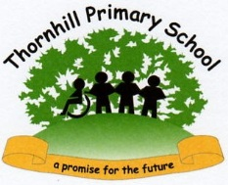
2026 ks2 SATs Results
National

School

Subject | Percentage of pupils achieving the expected standard: school | Percentage of pupils achieving the expected standard: national | Percentage achieving at a higher standard: school | Percentage achieving at a higher standard: national | Progress score: school | Progress score: national | Average scaled score: school | Average scaled score: national
English reading | 80% | 75% | 27% | N/A |  |  | 106.5 | 106
English grammar, punctuation and spelling | 86% | 74% | 43% | N/A |  |  | 108.6 | 105
Mathematics | 80% | 75% | 40% | N/A |  |  | 106.2 | 105
English writing (teacher assessment) | 83% | 72% | 40% | N/A
Reading, writing and maths combined | 73% | 63% | N/A | N/A
Science | 90% | 82% | N/A | N/A

